Lab - Use RESTCONF to Access an IOS XE Device
Name: Dawn Andrei Pamesa
Course and Section: CS0016 (NetComms 2), TS31-9
Activity: Lab Exercise 7.3 - Use RESTCONF to Access an IOS XE Device
Date: November 11, 2026

Objectives
Part 1: Build the Network and Verify Connectivity
Part 2: Configure an IOS XE Device for RESTCONF Access
Part 3: Open and Configure Postman
Part 4: Use Postman to Send GET Requests
Part 5: Use Postman to Send a PUT Request
Part 6: Use a Python Script to Send GET Requests
Part 7: Use a Python Script to Send a PUT Request

Background / Scenario
The RESTCONF protocol provides a simplified subset of NETCONF features over a RESTful API. RESTCONF allows you to make RESTful API calls to an IOS XE device. The data that is returned by the API can be formatted in either XML or JSON. In the first half of this lab, you will use the Postman program to construct and send API requests to the RESTCONF service that is running on the CSR1kv. In the second half of the lab, you will create Python scripts to perform the same tasks as your Postman program.

Required Resources
- 1 PC with operating system of your choice
- Virtual Box or VMWare
- DEVASC Virtual Machine
- CSR1kv Virtual Machine

Instructions

Launch the VMs and Verify Connectivity
In this Part, you launch the two VMs for course and verify connectivity. You will then establish a secure shell (SSH) connection.

Launch the VMs
If you have not already completed the Lab - Install the Virtual Machine Lab Environment and the Lab - Install the CSR1kv VM, do so now. If you have already completed these labs, launch both the DEVASC VM and CSR1000v VM now.

Verify connectivity between the VMs.
      - In the CSR1kv VM, press Enter to get a command prompt and then use show ip interface brief to verify that the IPv4 address is 192.168.56.101. If the address is different, make a note of it.
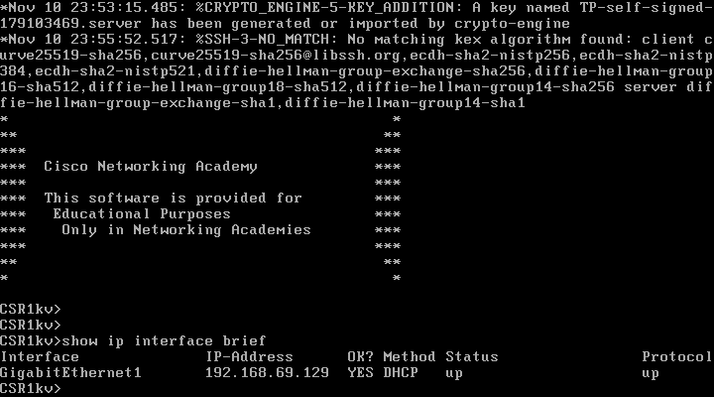
Screenshot 1: The CSR1kv console, where GigabitEthernet1 got the DHCP address 192.168.69.129. This address replaces the 192.168.56.101 in the sheet in every step below, since both VMs run on VMware.
      - Open terminal in the DEVASC VM.
      - Ping the CSR1kv to verify connectivity. You should have already done this in the installation labs. If you are not able to ping, then revisit those labs listed above in Part 1a.
devasc@labvm:~$ ping -c 5 192.168.56.101
PING 192.168.56.101 (192.168.56.101) 56(84) bytes of data.
64 bytes from 192.168.56.101: icmp_seq=1 ttl=254 time=1.37 ms
64 bytes from 192.168.56.101: icmp_seq=2 ttl=254 time=1.15 ms
64 bytes from 192.168.56.101: icmp_seq=3 ttl=254 time=0.981 ms
64 bytes from 192.168.56.101: icmp_seq=4 ttl=254 time=1.01 ms
64 bytes from 192.168.56.101: icmp_seq=5 ttl=254 time=1.14 ms

--- 192.168.56.101 ping statistics ---
5 packets transmitted, 5 received, 0% packet loss, time 4006ms
rtt min/avg/max/mdev = 0.981/1.130/1.365/0.135 ms
devasc@labvm:~$
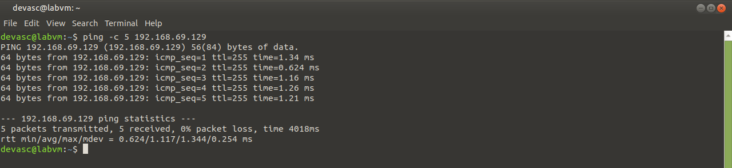
Screenshot 2: Ping from the DEVASC VM to the CSR1kv, with 5 packets sent and 5 received, which means 0% packet loss.

Verify SSH connectivity to the CSR1kv VM.
      - In the terminal for the DEVASC VM, SSH to the CSR1kv VM with the following command:
devasc@labvm:~$ ssh cisco@192.168.56.101
Note: The first time you SSH to the CSR1kv, your DEVASC VM warns you about the authenticity of the CSR1kv. Because you trust the CSR1kv, answer yes to the prompt.
The authenticity of host '192.168.56.101 (192.168.56.101)' can't be established.
RSA key fingerprint is SHA256:HYv9K5Biw7PFiXeoCDO/LTqs3EfZKBuJdiPo34VXDUY.
Are you sure you want to continue connecting (yes/no/[fingerprint])? yes
Warning: Permanently added '192.168.56.101' (RSA) to the list of known hosts.
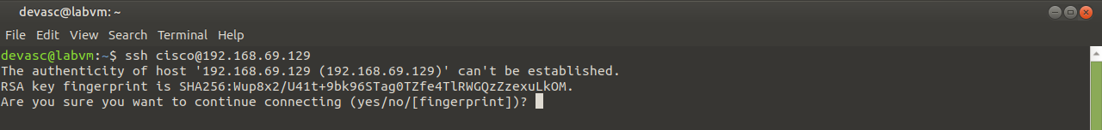
Screenshot 3: The first SSH connection asks to trust the router's RSA key, so the answer is yes.
      - Enter cisco123! as the password and you should now be at the privileged EXEC command prompt for the CSR1kv.
Password: <cisco123!>

CSR1kv#
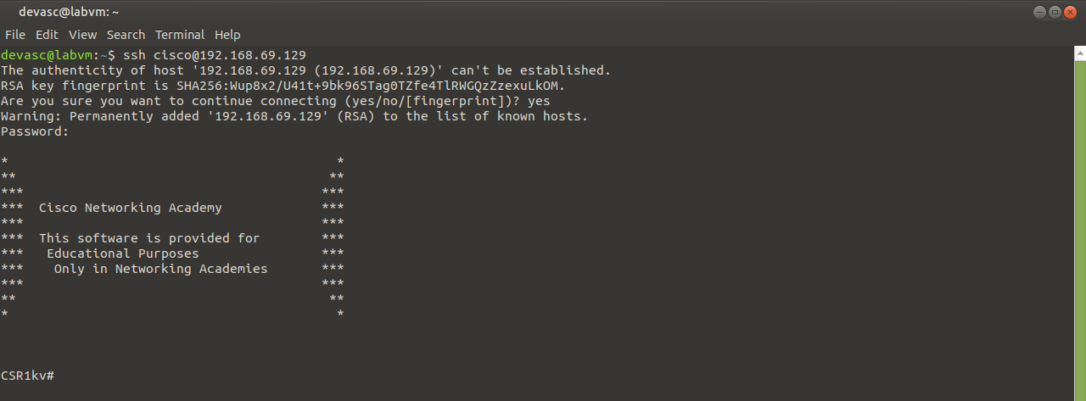
Screenshot 4: After the password, the SSH session lands on the CSR1kv# prompt.
      - Leave the SSH session open for the next Part.

Configure an IOS XE Device for RESTCONF Access
In this Part, you will configure the CSR1kv VM to accept RESTCONF messages. You will also start the HTTPS service.
Note: The services discussed in this Part may already be running on your VM. However, make sure you know the commands to view the running services and to enable them.

Verify that the RESTCONF daemons are running.
RESTCONF should already be running because it was part of the default configuration provided by NetAcad. From the terminal, you can use the show platform software yang-management process command to see if all the daemons associated with the RESTCONF service are running. The NETCONF daemon may also be running, but it won’t be used in this lab. If one or more of the required daemons are not running, proceed to Step 2.
Open configuration window
CSR1kv# show platform software yang-management process
confd : Running
nesd : Running
syncfd : Running
ncsshd : Running
dmiauthd : Running
nginx : Running
ndbmand : Running
pubd : Running

CSR1kv#
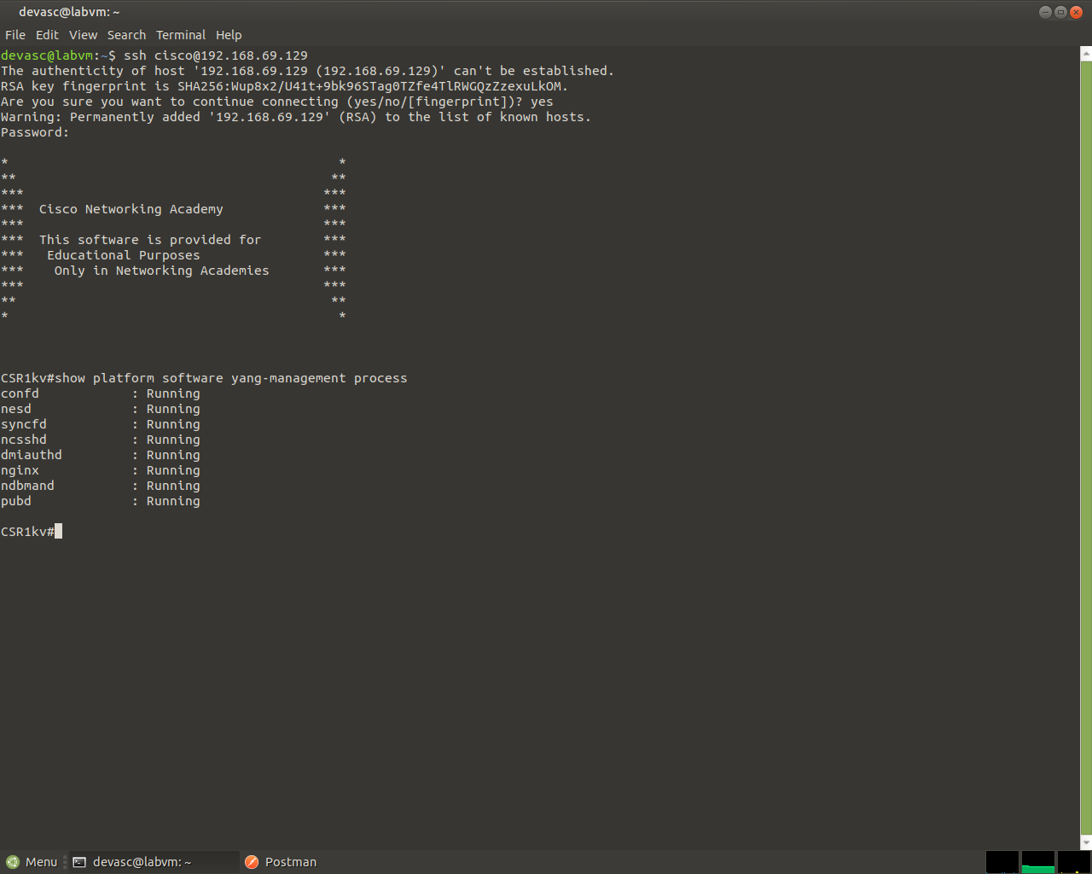
Screenshot 5: show platform software yang-management process, where confd, nesd, syncfd, ncsshd, dmiauthd, nginx, ndbmand and pubd are all Running, so RESTCONF was already on.
Note: The purpose and function of all the daemons is beyond the scope of this course.

Enable and verify the RESTCONF service.
      - Enter the global configuration command restconf to enable the RESTCONF service on the CSR1kv.
CSR1kv#configure terminal
CSR1kv(config)# restconf
      - Verify that the required RESTCONF daemons are now running. Recall that ncsshd is the NETCONF service, which may be running on your device. We do not need it for this lab. However, you do need nginx, which is the HTTPS server. This will allow you to make REST API calls to the RESTCONF service.
CSR1kv(config)# exit
CSR1kv# show platform software yang-management process
confd : Running
nesd : Running
syncfd : Running
ncsshd : Not Running
dmiauthd : Running
nginx : Not Running
ndbmand : Running
pubd : Running

Enable and verify the HTTPS service.
      - Enter the following global configuration commands to enable the HTTPS server and specify that server authentication should use the local database.
CSR1kv# configure terminal
CSR1kv(config)# ip http secure-server
CSR1kv(config)# ip http authentication local
      - Verify that the HTTPS server (nginx) is now running.
CSR1kv(config)# exit
CSR1kv# show platform software yang-management process
confd : Running
nesd : Running
syncfd : Running
ncsshd : Not Running
dmiauthd : Running
nginx : Running
ndbmand : Running
pubd : Running
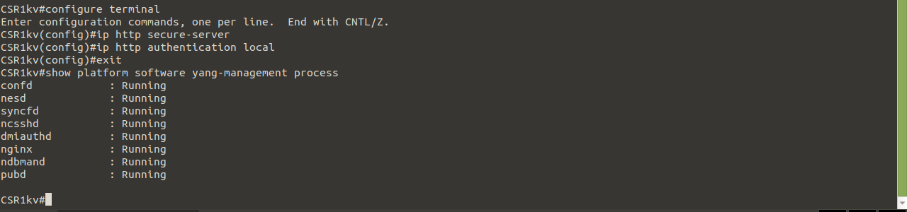
Screenshot 6: The restconf command, then ip http secure-server and ip http authentication local, each followed by the same show command, and all the daemons stay Running, including nginx for HTTPS.
Close configuration window

Open and Configure Postman
In this Part, you will open Postman, disable SSL certificates, and explore the user interface.

Open Postman.
      - In the DEVASC VM, open the Postman application.
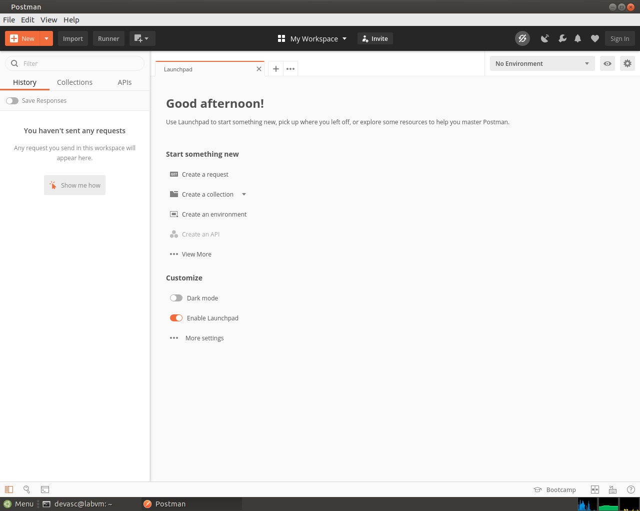
Screenshot 7: Postman, opened in the DEVASC VM, which went straight to the Launchpad without asking for an account.
      - If this is the first time you have opened Postman, it may ask you to create an account or sign in. At the bottom of the window, you can also click the “Skip” message to skip signing in. Signing in is not required to use this application.

Disable SSL certification verification.
By default, Postman has SSL certification verification turned on. You will not be using SSL certificates with the CSR1kv; therefore, you need to turn off this feature.
      - Click File > Settings.
      - Under the General tab, set the SSL certificate verification to OFF.
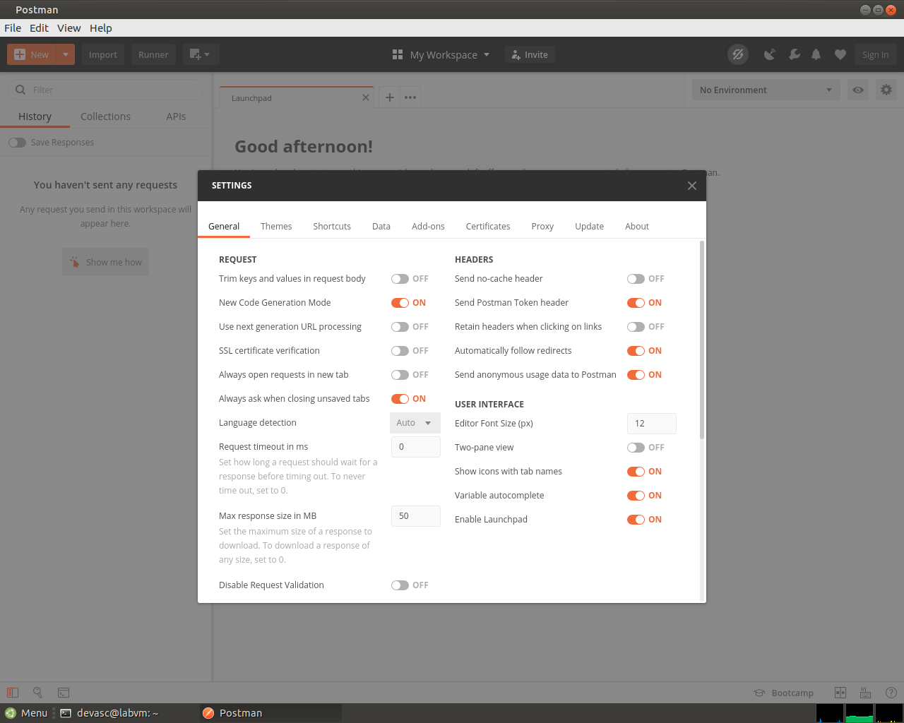
Screenshot 8: Settings, General tab, with SSL certificate verification switched OFF.
      - Close the Settings dialog box.

Use Postman to Send GET Requests
In this Part, you will use Postman to send a GET request to the CSR1kv to verify that you can connect to the RESTCONF service.

Explore the Postman user interface.
      - In the center, you will see the Launchpad. You can explore this area if you wish.
      - Click the plus sign (+) next to the Launchpad tab to open a GET Untitled Request. This interface is where you will do all of your work in this lab.
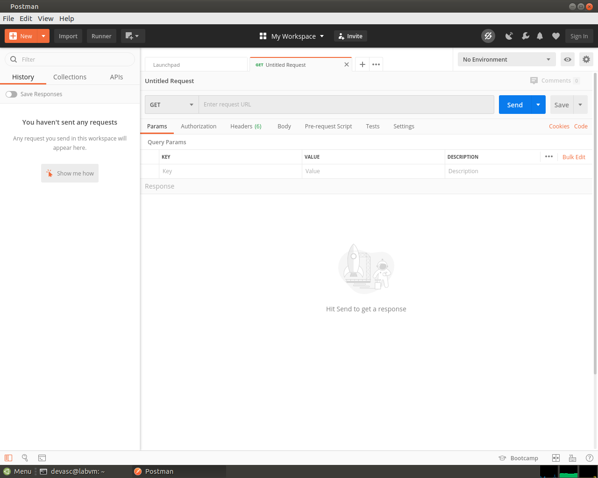
Screenshot 9: The plus sign opened a new request tab, which is a GET Untitled Request.

Enter the URL for the CSR1kv.
      - The request type is already set to GET. Leave the request type set to GET.
      - In the “Enter request URL” field, type in the URL that will be used to access the RESTCONF service that is running on the CSR1kv:
https://192.168.56.101/restconf/
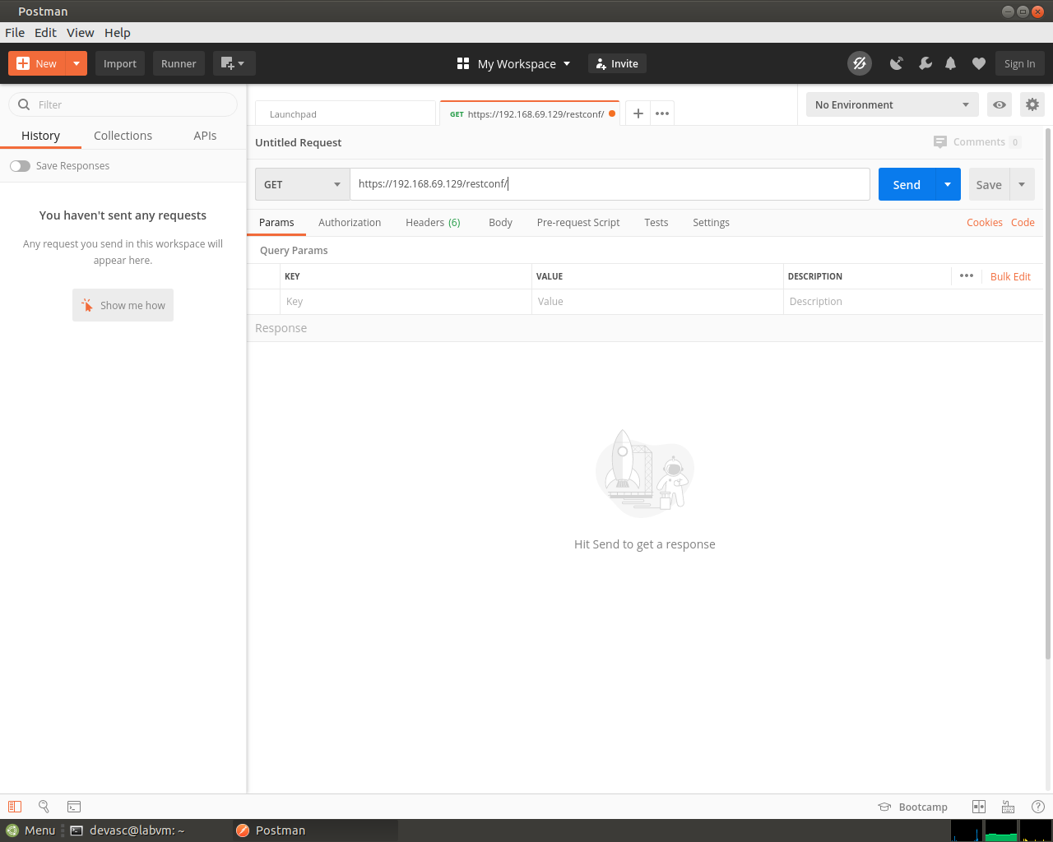
Screenshot 10: The RESTCONF URL typed in, using the router's address 192.168.69.129.

Enter authentication credentials.
Under the URL field, there are tabs listed for Params, Authorization, Headers, Body, Pre-request Script, Test, and Settings. In this lab, you will use Authorization, Headers, and Body.
      - Click the Authorization tab.
      - Under Type, click the down arrow next to “Inherit auth from parent” and choose Basic Auth.
      - For Username and Password, enter the local authentication credentials for the CSR1kv:
Username: cisco
Password: cisco123!
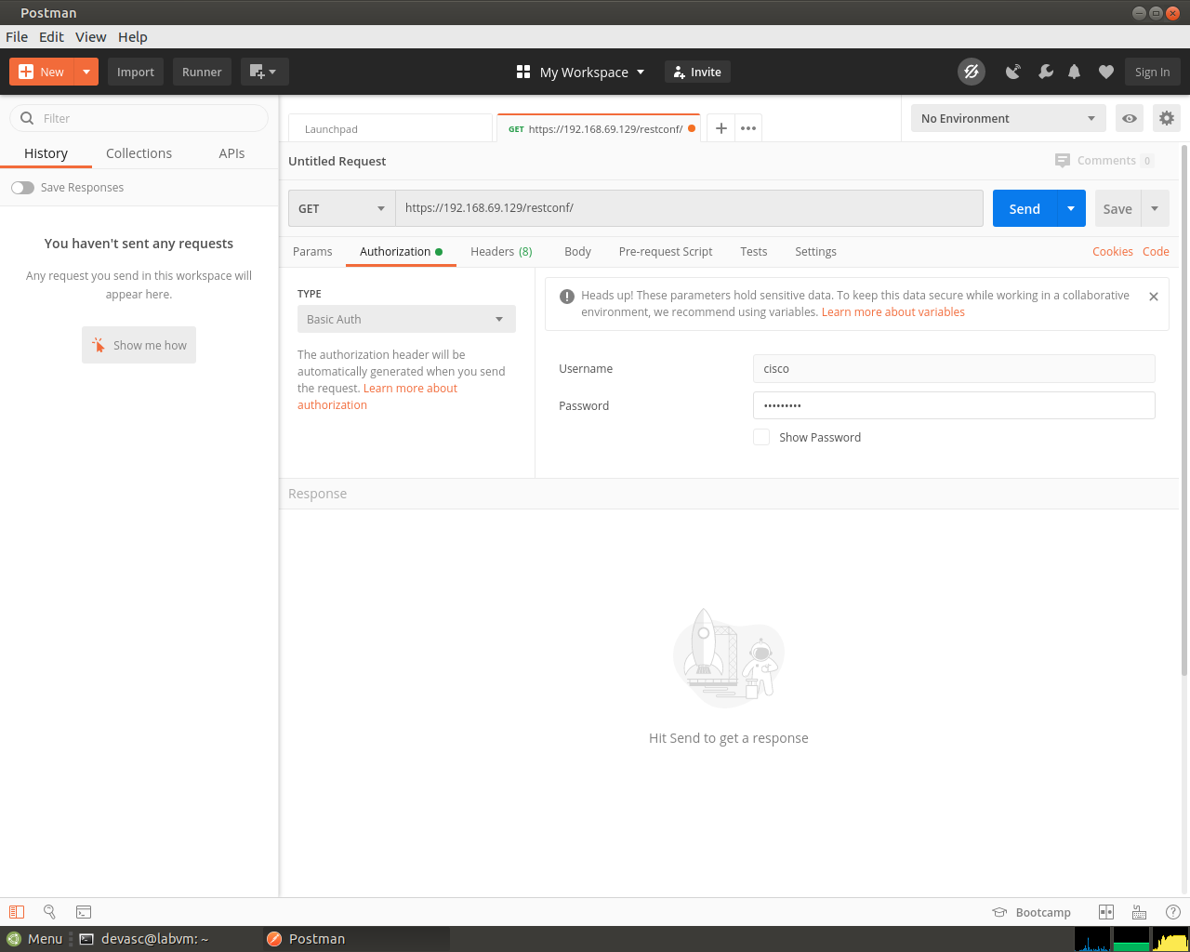
Screenshot 11: The Authorization tab set to Basic Auth, with the username cisco and the password masked.
      - Click Headers. Then click the 7 hidden. You can verify that the Authorization key has a Basic value that will be used to authenticate the request when it is sent to the CSR1kv.

Set JSON as the data type to send to and receive from the CSR1kv.
You can send and receive data from the CSR1kv in XML or JSON format. For this lab, you will use JSON.
      - In the Headers area, click in the first blank Key field and type Content-Type for the type of key. In the Value field, type application/yang-data+json. This tells Postman to send JSON data to the CSR1kv.
      - Below your Content-Type key, add another key/value pair. The Key field is Accept and the Value field is application/yang-data+json.
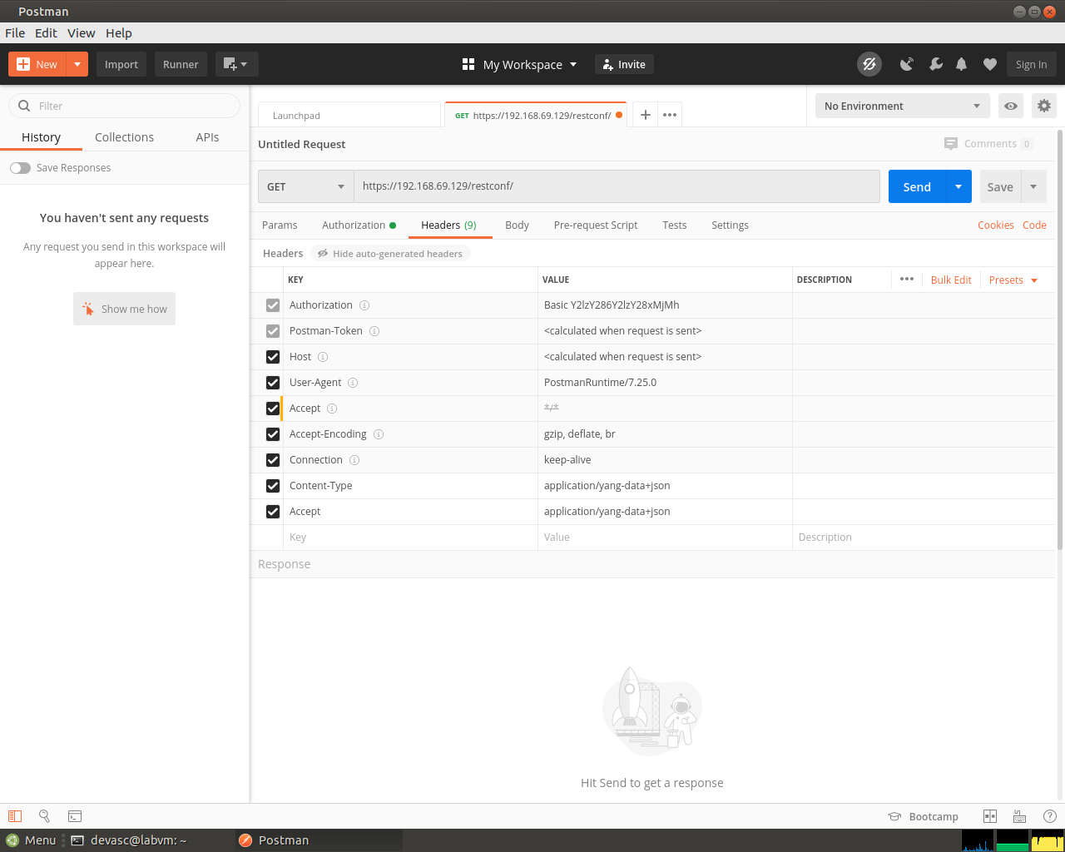
Screenshot 12: The Headers tab, where the hidden headers show Authorization: Basic, and Content-Type and Accept are both application/yang-data+json.
Note: You can change application/yang-data+json to application/yang-data+xml to send and receive XML data instead of JSON data, if necessary.

Send the API request to the CSR1kv.
Postman now has all the information it needs to send the GET request. Click Send. Below Temporary Headers, you should see the following JSON response from the CSR1kv. If not, verify that you completed the previous steps in this part of the lab and correctly configured RESTCONF and HTTPS service in Part 2.
{
"ietf-restconf:restconf": {
"data": {},
"operations": {},
"yang-library-version": "2016-06-21"
}
}
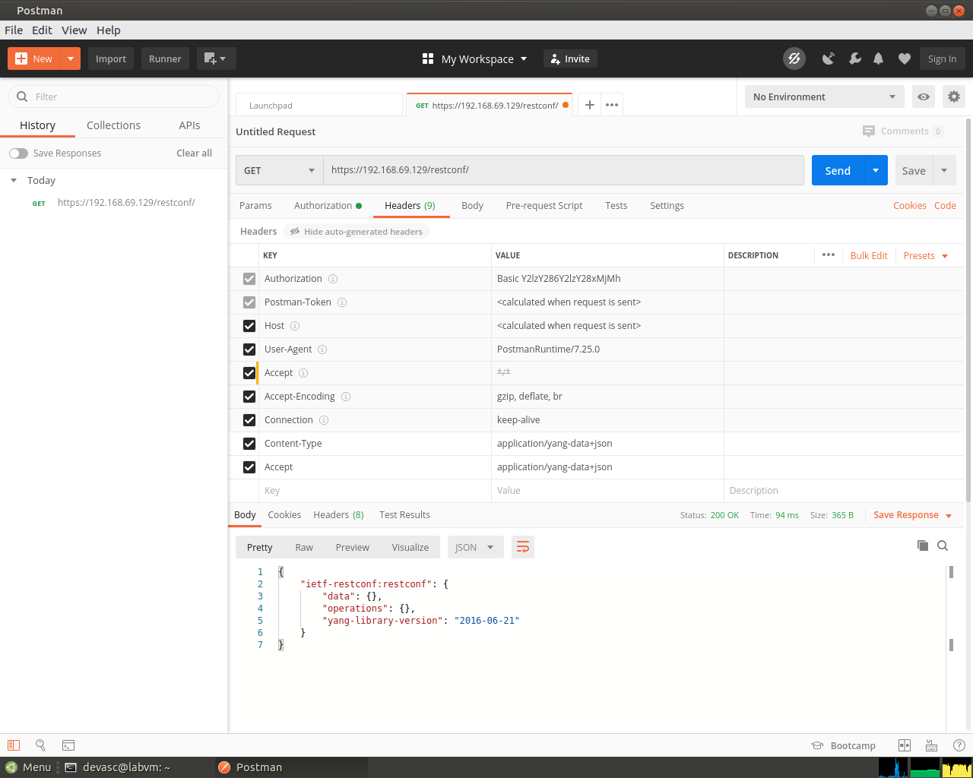
Screenshot 13: Send returned Status: 200 OK, with the ietf-restconf:restconf JSON, which shows Postman can talk to the CSR1kv.
This JSON response verifies that Postman can now send other REST API requests to the CSR1kv.

Use a GET request to gather the information for all interfaces on the CSR1kv.
      - Now that you have a successful GET request, you can use it as a template for additional requests. At the top of Postman, next to the Launchpad tab, right-click the GET tab that you just used and choose Duplicate Tab.
      - Use the ietf-interfaces YANG model to gather interface information. For the URL, add data/ietf-interfaces:interfaces:
https://192.168.56.101/restconf/data/ietf-interfaces:interfaces
      - Click Send. You should see a JSON response from the CSR1kv that is similar to the output shown below. Your output may be different depending on your particular router.
{
"ietf-interfaces:interfaces": {
"interface": [
{
"name": "GigabitEthernet1",
"description": "VBox",
"type": "iana-if-type:ethernetCsmacd",
"enabled": true,
"ietf-ip:ipv4": {},
"ietf-ip:ipv6": {}
}
]
}
}
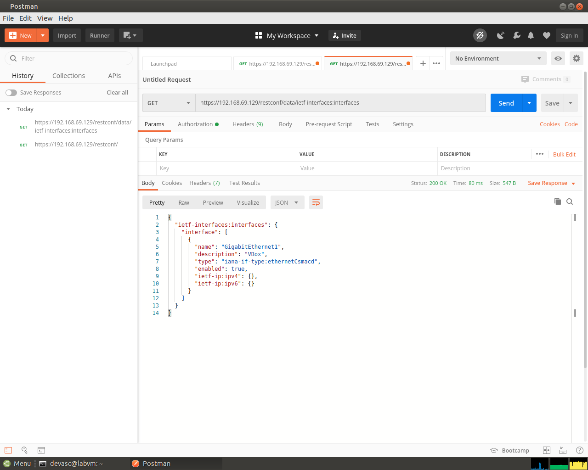
Screenshot 14: The GET for ietf-interfaces:interfaces returns GigabitEthernet1 only, and its ipv4 is empty.

Use a GET request to gather information for a specific interface on the CSR1kv.
In this lab, only the GigabitEthernet1 interface is configured. To specify just this interface, extend the URL to only request information for this interface.
      - Duplicate your last GET request.
      - Add the interface= parameter to specify an interface and type in the name of the interface.
https://192.168.56.101/restconf/data/ietf-interfaces:interfaces/interface=GigabitEthernet1
Note: If you request interface information from a different Cisco device with names that use forward slashes, such as GigabitEthernet0/0/1, use the HTML code %2F for the forward slashes in the interface name. So, 0/0/1 becomes 0%2F0%2F1.
      - Click Send. You should see a JSON response from the CSR1kv that is similar to output below. Your output may be different depending on your particular router. In the default CSR1kv setup, you will not see IP addressing information.
{
"ietf-interfaces:interface": {
"name": "GigabitEthernet1",
"description": "VBox",
"type": "iana-if-type:ethernetCsmacd",
"enabled": true,
"ietf-ip:ipv4": {},
"ietf-ip:ipv6": {}
}
}
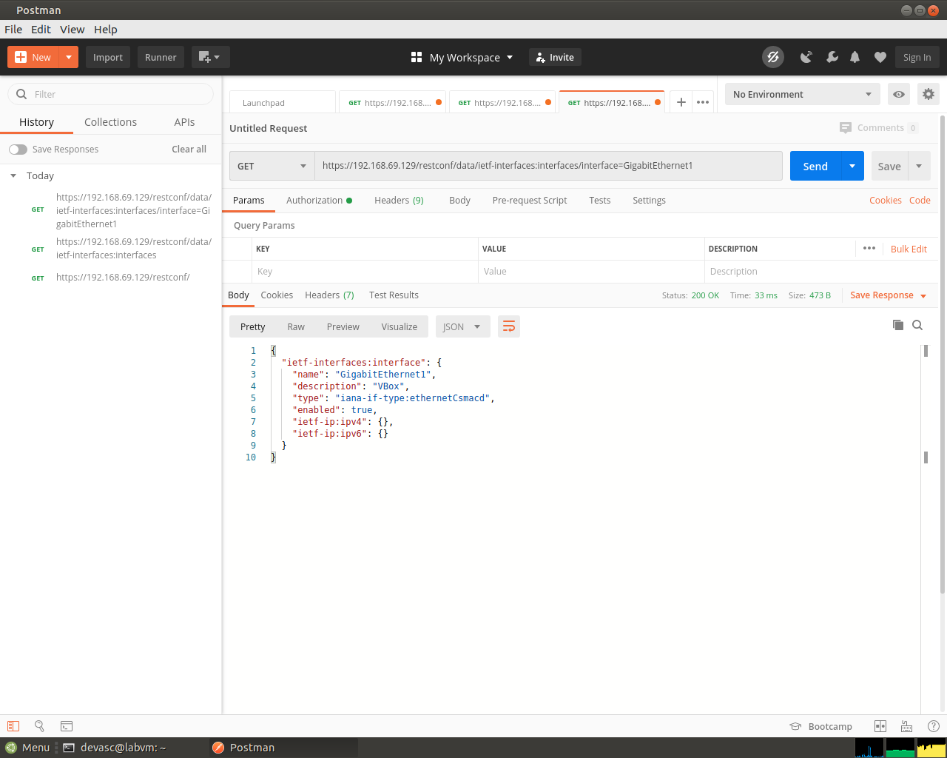
Screenshot 15: Adding /interface=GigabitEthernet1 to the URL returns just that interface, which still has no IPv4 information.
      - This interface receives addressing from a Virtual Box template. Therefore, the IPv4 address is not shown under show running-config. Instead, you will see the ip address dhcp command. You can see this also in the show ip interface brief output.
CSR1kv# show ip interface brief
Interface IP-Address OK? Method Status Protocol
GigabitEthernet1 192.168.56.101 YES DHCP up up
CSR1kv#
      - In the next Part you will need to use the JSON response from a manually configurated interface. Open a command terminal with the CSR1kv and manually configure the GigabitEthernet1 interface with the same IPv4 address currently assigned to it by Virtual Box.
CSR1kv# conf t
CSR1kv(config)# interface g1
CSR1kv(config-if)# ip address 192.168.56.101 255.255.255.0
CSR1kv(config-if)# end
CSR1kv# show ip interface brief
Interface IP-Address OK? Method Status Protocol
GigabitEthernet1 192.168.56.101 YES manual up up
CSR1kv#
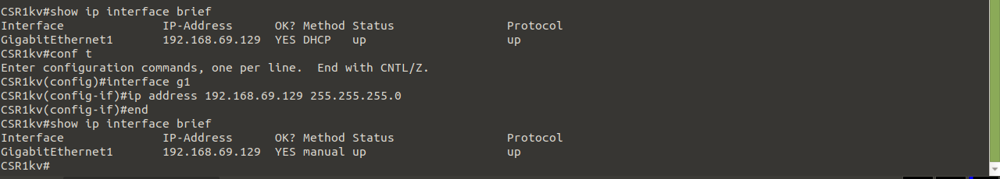
Screenshot 16: The interface got its address from DHCP, so I set the same address, 192.168.69.129, as a static address on g1. The method column changed from DHCP to manual.
      - Return to Postman and send your GET request again. You should now see IPv4 addressing information in the JSON response, as shown below. In the next Part, you will copy this JSON format to create a new interface.
{
"ietf-interfaces:interface": {
"name": "GigabitEthernet1",
"description": "VBox",
"type": "iana-if-type:ethernetCsmacd",
"enabled": true,
"ietf-ip:ipv4": {
"address": [
{
"ip": "192.168.56.101",
"netmask": "255.255.255.0"
}
]
},
"ietf-ip:ipv6": {}
}
}
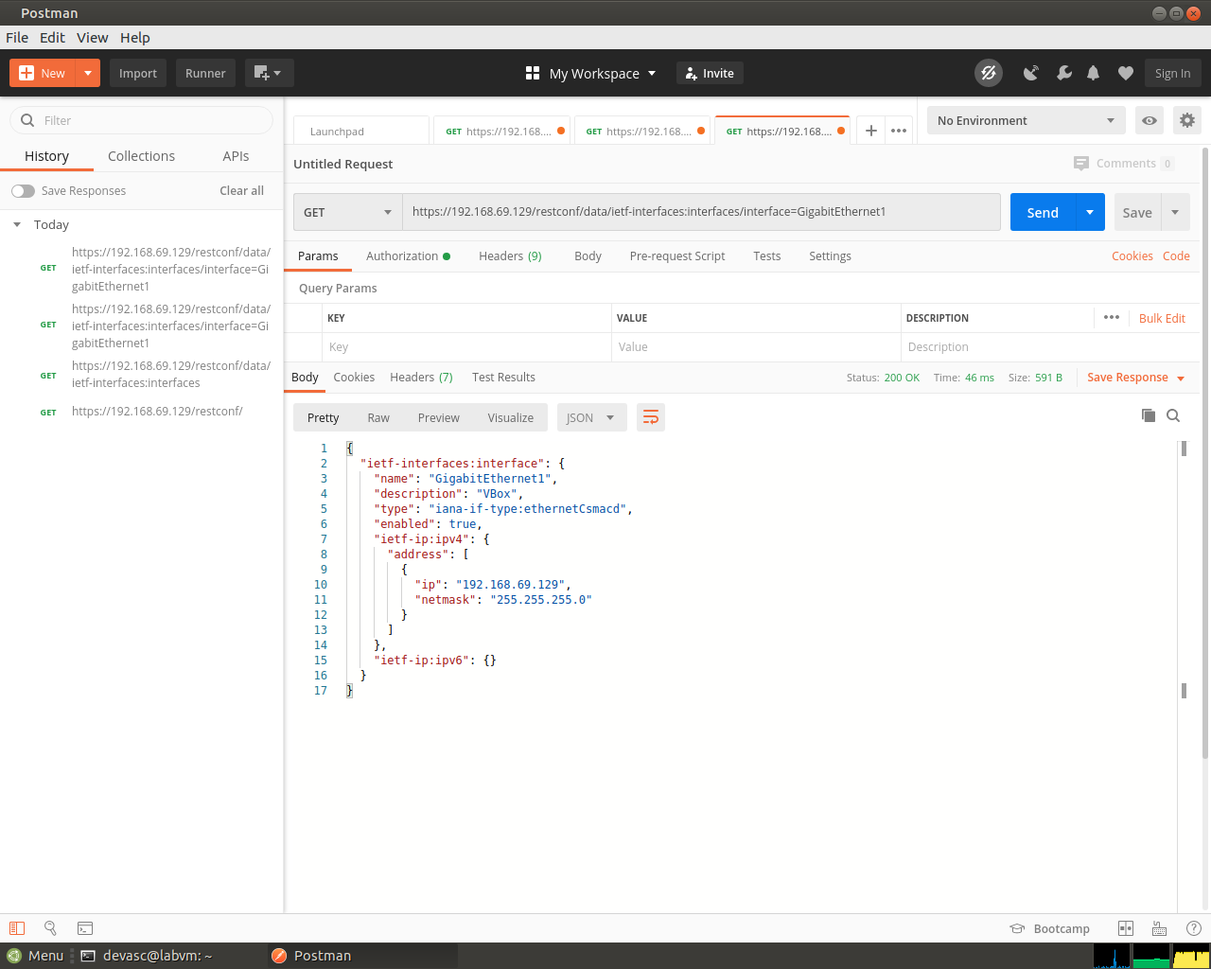
Screenshot 17: After the static address, the same GET shows the ipv4 address 192.168.69.129 with the netmask 255.255.255.0.

Use Postman to Send a PUT Request
In this Part, you will configure Postman to send a PUT request to the CSR1kv to create a new loopback interface.
Note: If you created a Loopback interface in another lab, either remove it now or create a new one by using a different number.

Duplicate and modify the last GET request.
      - Duplicate the last GET request.
      - For the Type of request, click the down arrow next to GET and choose PUT.
      - For the interface= parameter, change it to =Loopback1 to specify a new interface.
https://192.168.56.101/restconf/data/ietf-interfaces:interfaces/interface=Loopback1

Configure the body of the request specifying the information for the new loopback.
      - To send a PUT request, you need to provide the information for the body of the request. Next to the Headers tab, click Body. Then click the Raw radio button. The field is currently empty. If you click Send now, you will get error code 400 Bad Request because Loopback1 does not exist yet and you did not provide enough information to create the interface.
      - Fill in the Body section with the required JSON data to create a new Loopback1 interface. You can copy the Body section of the previous GET request and modify it. Or you can copy the following into the Body section of your PUT request. Notice that the type of interface must be set to softwareLoopback.
{
"ietf-interfaces:interface": {
"name": "Loopback1",
"description": "My first RESTCONF loopback",
"type": "iana-if-type:softwareLoopback",
"enabled": true,
"ietf-ip:ipv4": {
"address": [
{
"ip": "10.1.1.1",
"netmask": "255.255.255.0"
}
]
},
"ietf-ip:ipv6": {}
}
}
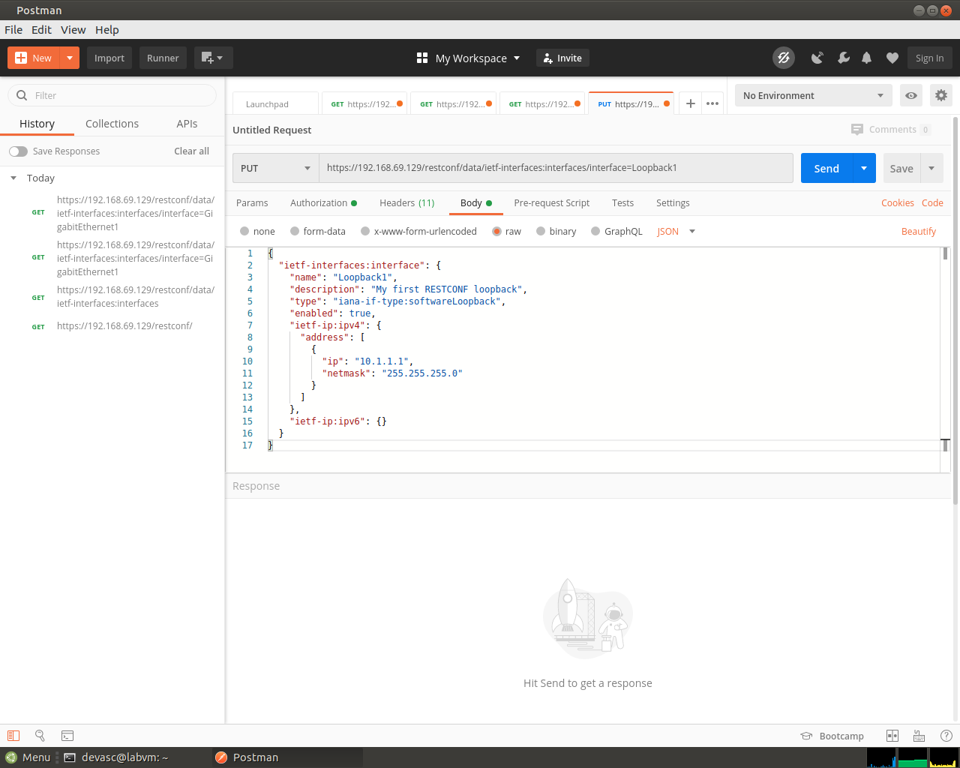
Screenshot 18: The duplicated request is now a PUT for interface=Loopback1, with the raw JSON body that has the type softwareLoopback and the address 10.1.1.1.
      - Click Send to send the PUT request to the CSR1kv. Below the Body section, you should see the HTTP response code Status: 201 Created. This indicates that the resource was created successfully.
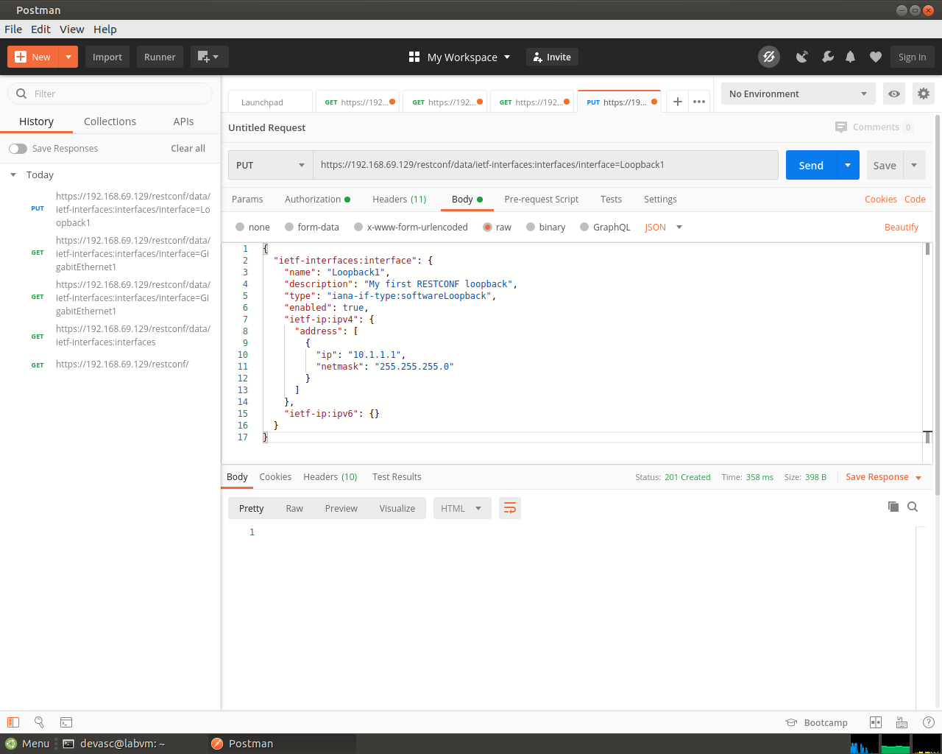
Screenshot 19: Send returned Status: 201 Created, which means the Loopback1 interface was created.
      - You can verify that the interface was created. Return to your SSH session with the CSR1kv and enter show ip interface brief. You can also run the Postman tab that contains the request to get information about the interfaces on the CSR1kv that was created in the previous Part of this lab.
Open configuration window
CSR1kv# show ip interface brief
Interface IP-Address OK? Method Status Protocol
GigabitEthernet1 192.168.56.101 YES manual up up
Loopback1 10.1.1.1 YES other up up
CSR1kv#
Screenshot 20: show ip interface brief on the router lists Loopback1 at 10.1.1.1, up and up.
Close configuration window

Use a Python script to Send GET Requests
In this Part, you will create a Python script to send GET requests to the CSR1kv.

Create the RESTCONF directory and start the script.
      - Open VS code. Then click File > Open Folder... and navigate to the devnet-src directory. Click OK.
      - Open a terminal window in VS Code: Terminal > New Terminal.
      - Create a subdirectory called restconf in the /devnet-src directory.
devasc@labvm:~/labs/devnet-src$ mkdir restconf
devasc@labvm:~/labs/devnet-src$
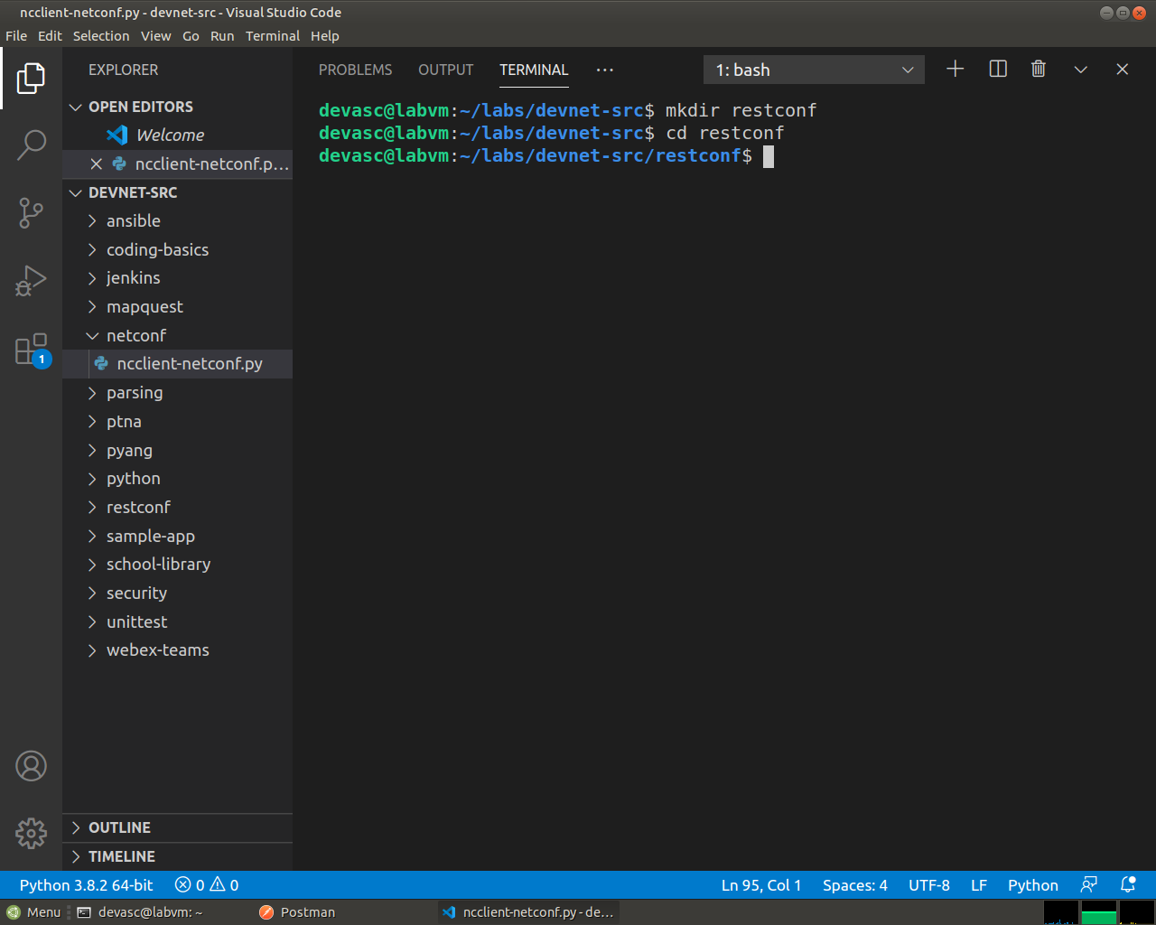
Screenshot 21: The restconf folder, created inside devnet-src from the VS Code terminal.
      - In the EXPLORER pane under DEVNET-SRC, right-click the restconf directory and choose New File.
      - Name the file restconf-get.py.
      - Enter the following commands to import the modules that are required and disable SSL certificate warnings:
import json
import requests
requests.packages.urllib3.disable_warnings()
The json module includes methods to convert JSON data to Python objects and vice versa. The requests module has methods that will let you send REST requests to a URL.

Create the variables that will be the components of the request.
      - Create a variable named api_url and assign it the URL that will access the interface information on the CSR1kv.
api_url = "https://192.168.56.101/restconf/data/ietf-interfaces:interfaces"
      - Create a dictionary variable named headers that has keys for Accept and Content-type and assign the keys the value application/yang-data+json.
headers = { "Accept": "application/yang-data+json",
"Content-type":"application/yang-data+json"
}
      - Create a Python tuple variable named basicauth that has two keys needed for authentication, username and password.
basicauth = ("cisco", "cisco123!")

Create a variable to send the request and store the JSON response.
Use the variables that were created in the previous step as parameters for the requests.get() method. This method sends an HTTP GET request to the RESTCONF API on the CSR1kv. Assign the result of the request to a variable named resp. That variable will hold the JSON response from the API. If the request is successful, the JSON will contain the returned YANG data model.
      - Enter the following statement:
resp = requests.get(api_url, auth=basicauth, headers=headers, verify=False)
The table below lists the various elements of this statement:
Element | Explanation
resp | The variable to hold the response from the API
requests.get() | The method that actually makes the GET request
api_url | The variable that holds the URL address string
auth | The tuple variable created to hold the authentication information
headers=headers | A parameter that is assigned the headers variable
verify=False | Disables verification of the SSL certificate when the request is made
      - To see the HTTP response code, add a print statement.
print(resp)
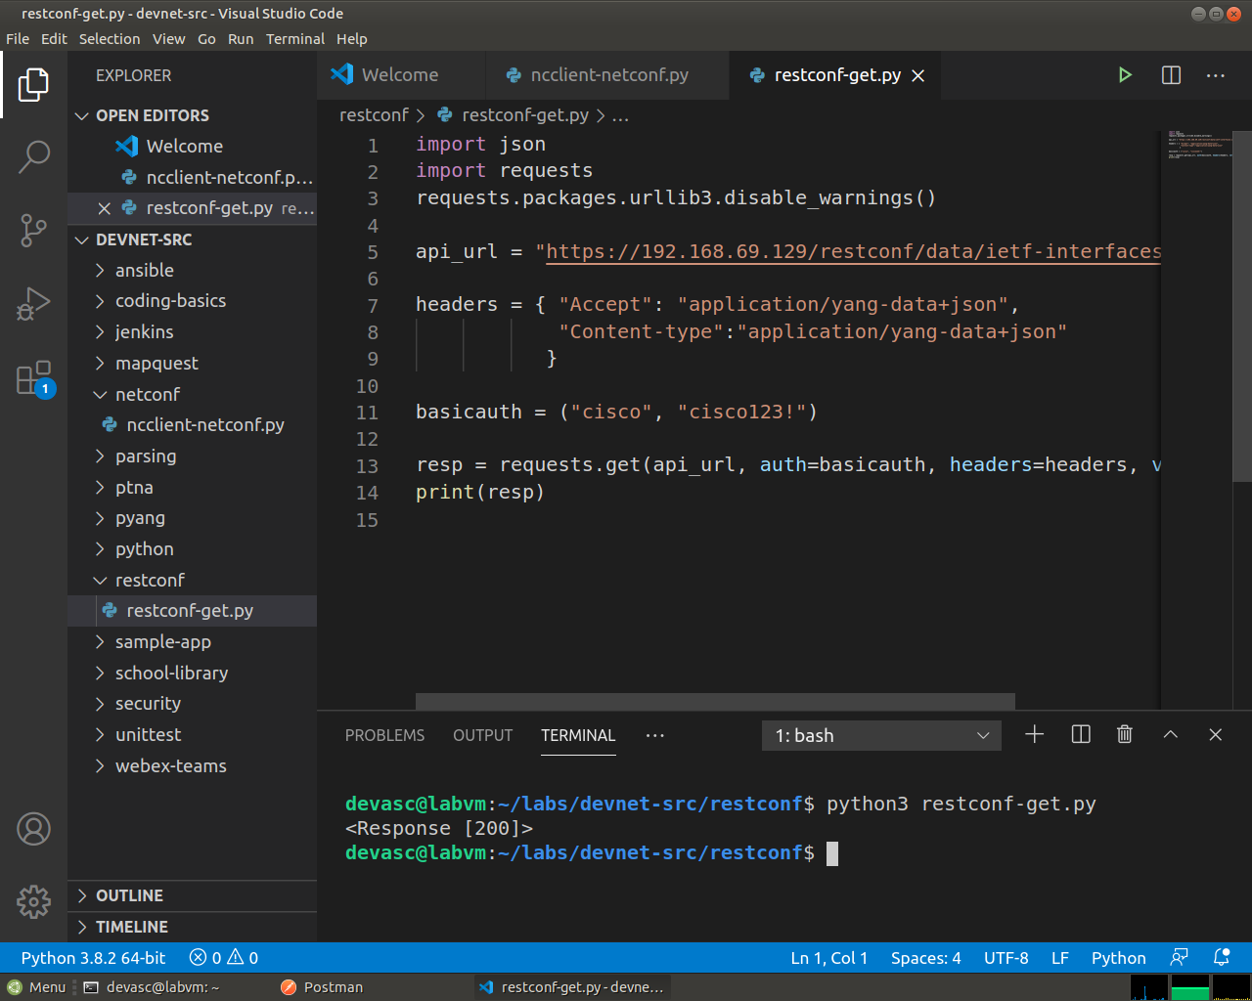
Screenshot 22: restconf-get.py with the imports, api_url, headers, basicauth and the requests.get() call.
      - Save and run your script. You should get the output shown below. If not, verify all previous steps in this part as well as the SSH and RESTCONF configuration for the CSR1kv.
devasc@labvm:~/labs/devnet-src$ cd restconf/
devasc@labvm:~/labs/devnet-src/restconf$ python3 restconf-get.py
<Response [200]>
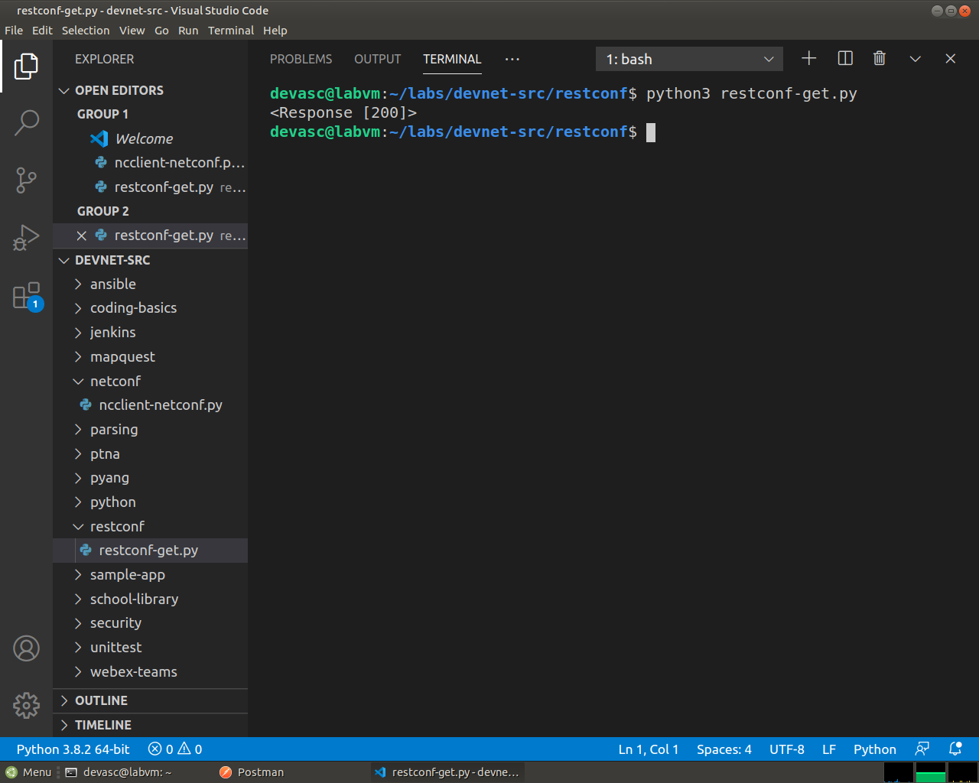
Screenshot 23: Running the script prints <Response [200]>, so the request worked.
devasc@labvm:~/labs/devnet-src/restconf$

Format and display the JSON data received from the CSR1kv.
Now you can extract the YANG model response values from the response JSON.
      - The response JSON is not compatible with Python dictionary and list objects, so it must be converted to Python format. Create a new variable called response_json and assign the variable resp to it. Add the json() method to convert the JSON. The statement is as follows:
response_json = resp.json()
      - Add a print statement to display the JSON data.
print(response_json)
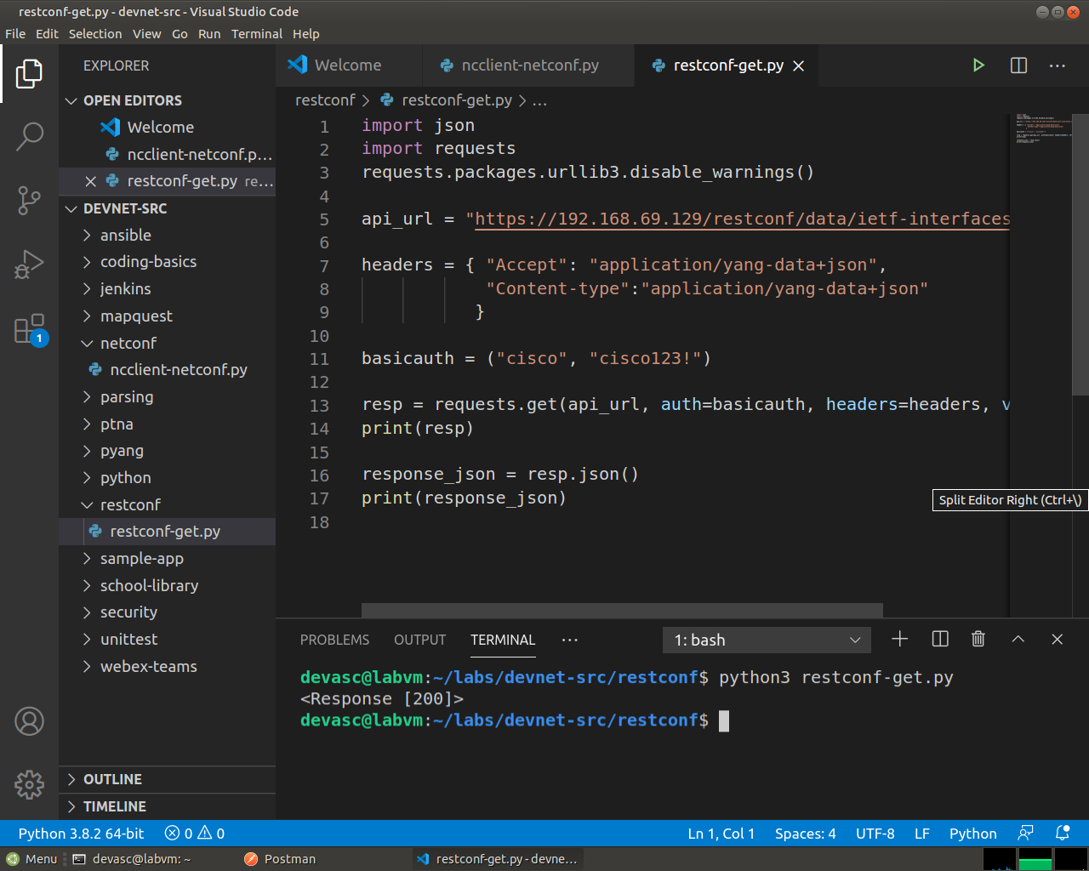
Screenshot 24: response_json = resp.json() was added, with a print for the JSON data.
      - Save and run your script. You should get output similar to the following:
devasc@labvm:~/labs/devnet-src/restconf$ python3 restconf-get.py
<Response [200]>
{'ietf-interfaces:interfaces': {'interface': [{'name': 'GigabitEthernet1', 'description': 'VBox', 'type': 'iana-if-type:ethernetCsmacd', 'enabled': True, 'ietf-ip:ipv4': {'address': [{'ip': '192.168.56.101', 'netmask': '255.255.255.0'}]}, 'ietf-ip:ipv6': {}}, {'name': 'Loopback1', 'description': 'My first RESTCONF loopback', 'type': 'iana-if-type:softwareLoopback', 'enabled': True, 'ietf-ip:ipv4': {'address': [{'ip': '10.1.1.1', 'netmask': '255.255.255.0'}]}, 'ietf-ip:ipv6': {}}]}}
devasc@labvm:~/labs/devnet-src/restconf$
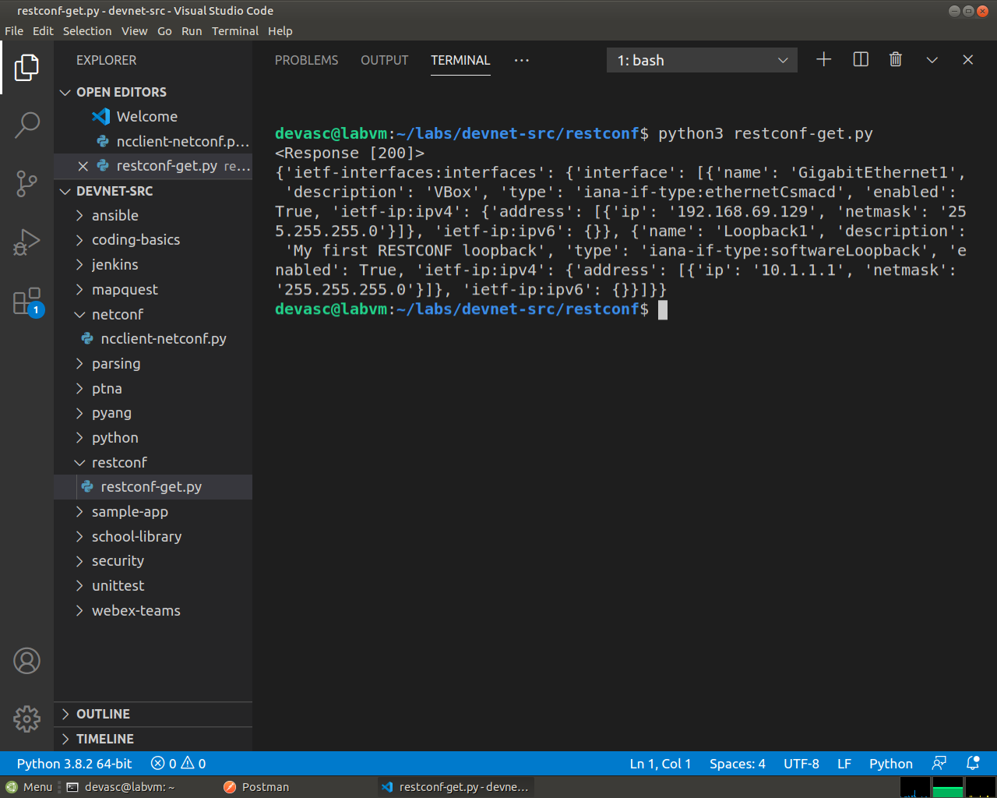
Screenshot 25: The output now has the data as a Python dictionary, with GigabitEthernet1 and Loopback1 in the interface list.
      - To prettify the output, edit your print statement to use the json.dumps() function with the “indent” parameter:
print(json.dumps(response_json, indent=4))
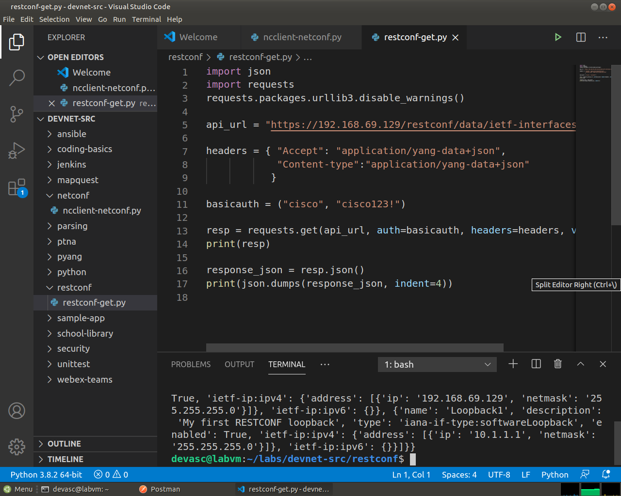
Screenshot 26: The print statement changed to json.dumps() with indent=4.
      - Save and run your script. You should get the output shown below. This output is virtually identical to the output of your first Postman GET request.
devasc@labvm:~/labs/devnet-src/restconf$ python3 restconf-get.py
<Response [200]>
{
"ietf-interfaces:interfaces": {
"interface": [
{
"name": "GigabitEthernet1",
"description": "VBox",
"type": "iana-if-type:ethernetCsmacd",
"enabled": true,
"ietf-ip:ipv4": {
"address": [
{
"ip": "192.168.56.101",
"netmask": "255.255.255.0"
}
]
},
"ietf-ip:ipv6": {}
},
{
"name": "Loopback1",
"description": "My first RESTCONF loopback",
"type": "iana-if-type:softwareLoopback",
"enabled": true,
"ietf-ip:ipv4": {
"address": [
{
"ip": "10.1.1.1",
"netmask": "255.255.255.0"
}
]
},
"ietf-ip:ipv6": {}
}
]
}
}
devasc@labvm:~/labs/devnet-src/restconf$
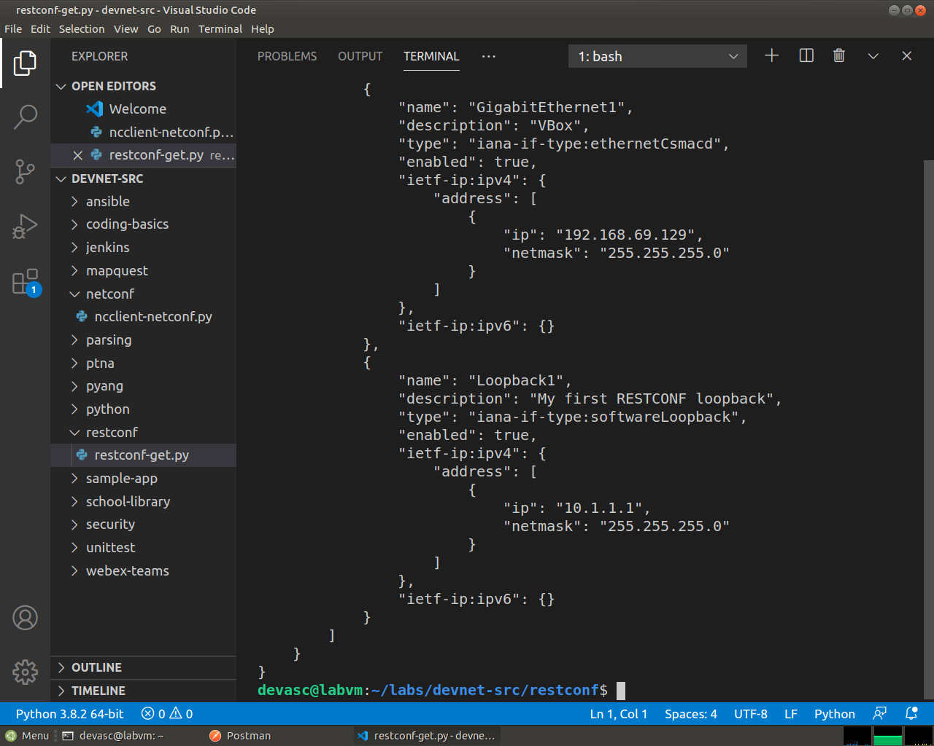
Screenshot 27: The same data, now formatted, which is almost the same as the Postman response.

Use a Python Script to Send a PUT Request
In this Part, you will create a Python script to send a PUT request to the CSR1kv. As was done in Postman, you will create a new loopback interface.

Import modules and disable SSL warnings.
      - In the EXPLORER pane under DEVNET-SRC, right-click the restconf directory and choose New File.
      - Name the file restconf-put.py.
      - Enter the following commands to import the modules that are required and disable SSL certificate warnings:
import json
import requests
requests.packages.urllib3.disable_warnings()

Create the variables that will be the components of the request.
      - Create a variable named api_url and assign it the URL that targets a new Loopback2 interface.
Note: This variable specification should be on one line in your script.
api_url = "https://192.168.56.101/restconf/data/ietf-interfaces:interfaces/interface=Loopback2"
      - Create a dictionary variable named headers that has keys for Accept and Content-type and assign the keys the value application/yang-data+json.
headers = { "Accept": "application/yang-data+json",
"Content-type":"application/yang-data+json"
}
      - Create a Python tuple variable named basicauth that has two values needed for authentication, username and password.
basicauth = ("cisco", "cisco123!")
      - Create a Python dictionary variable yangConfig that will hold the YANG data that is required to create the new interface Loopback2. You can use the same dictionary that you used previously in Postman. However, change the interface number and address. Also, be aware that Boolean values must be capitalized in Python. Therefore, make sure that the T is capitalized in the key/value pair for “enabled”: True.
yangConfig = {
"ietf-interfaces:interface": {
"name": "Loopback2",
"description": "My second RESTCONF loopback",
"type": "iana-if-type:softwareLoopback",
"enabled": True,
"ietf-ip:ipv4": {
"address": [
{
"ip": "10.2.1.1",
"netmask": "255.255.255.0"
}
]
},
"ietf-ip:ipv6": {}
}
}

Create a variable to send the request and store the JSON response.
Use the variables created in the previous step as parameters for the requests.put() method. This method sends an HTTP PUT request to the RESTCONF API. Assign the result of the request to a variable named resp. That variable will hold the JSON response from the API. If the request is successful, the JSON will contain the returned YANG data model.
      - Before entering statements, please note that this variable specification should be on only one line in your script. Enter the following statements:
Note: This variable specification should be on one line in your script.
resp = requests.put(api_url, data=json.dumps(yangConfig), auth=basicauth, headers=headers, verify=False)
      - Enter the code below to handle the response. If the response is one of the HTTP success messages, the first message will be printed. Any other code value is considered an error. The response code and error message will be printed in the event that an error has been detected.
if(resp.status_code >= 200 and resp.status_code <= 299):
print("STATUS OK: {}".format(resp.status_code))
else:
print('Error. Status Code: {} \nError message: {}'.format(resp.status_code,resp.json()))
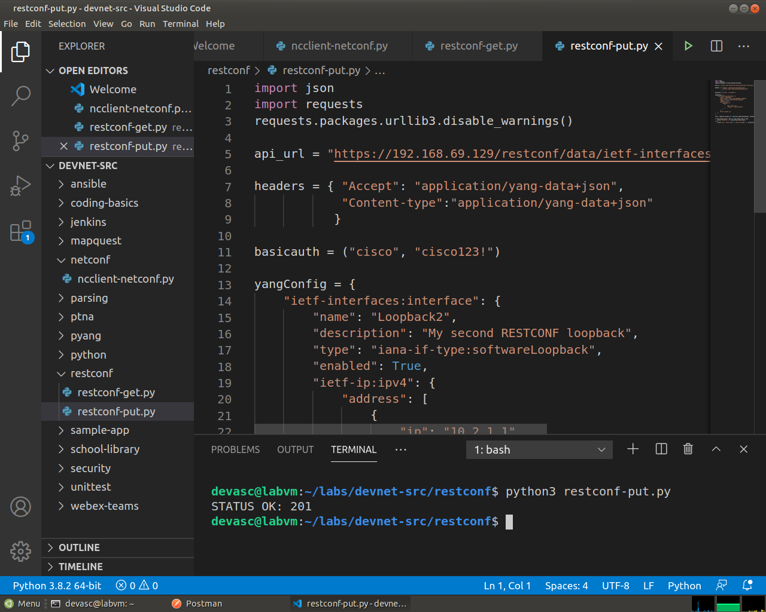
Screenshot 28: restconf-put.py, which targets Loopback2, sets yangConfig with the address 10.2.1.1, and sends it with requests.put().
The table below lists the various elements of these statements:
Element | Explanation
resp | The variable to hold the response from the API.
requests.put() | The method that makes the PUT request.
api_url | The variable that holds the URL address string.
data | The data to be sent to the API endpoint, which is formatted as JSON.
auth | The tuple variable created to hold the authentication information.
headers=headers | A parameter that is assigned the headers variable.
verify=False | A parameter that disables verification of the SSL certificate when the request is made.
resp.status_code | The HTTP status code in the API PUT request reply.
      - Save and run the script to send the PUT request to the CSR1kv. You should get a 201 Status Created message. If not, check your code and the configuration for the CSR1kv.
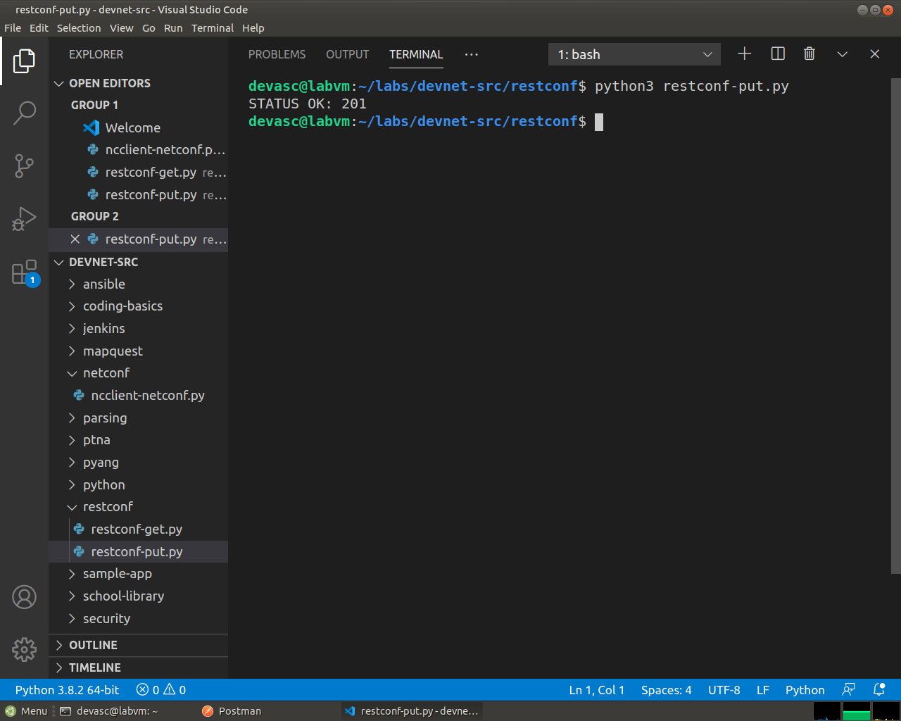
Screenshot 29: The script prints STATUS OK: 201, which means the interface was created.
      - You can verify that the interface was created by entering show ip interface brief on the CSR1kv.
Open configuration window
CSR1kv# show ip interface brief
Interface IP-Address OK? Method Status Protocol
GigabitEthernet1 192.168.56.101 YES manual up up
Loopback1 10.1.1.1 YES other up up
Loopback2 10.2.1.1 YES other up up
CSR1kv#
Screenshot 30: show ip interface brief on the router lists Loopback1 and Loopback2, both up and up.
Close configuration window
To conclude, RESTCONF let the DEVASC VM read and change the CSR1kv over HTTPS with JSON, first through Postman and then through two short Python scripts that use the requests module. A GET returned the interface data with a 200 status, and each PUT created a new Loopback with a 201 status. After the lab, both Loopbacks were removed and GigabitEthernet1 went back to DHCP, so the router has its original configuration.

Programs Used in this Lab
The following Python scripts were used in this lab:
#===================================================================
#resconf-get.py
import json
import requests
requests.packages.urllib3.disable_warnings()

api_url = "https://192.168.56.101/restconf/data/ietf-interfaces:interfaces"

headers = { "Accept": "application/yang-data+json",
"Content-type":"application/yang-data+json"
}

basicauth = ("cisco", "cisco123!")

resp = requests.get(api_url, auth=basicauth, headers=headers, verify=False)

print(resp)

response_json = resp.json()
print(json.dumps(response_json, indent=4))

#end of file

#===================================================================
#resconf-put.py
import json
import requests
requests.packages.urllib3.disable_warnings()

api_url = "https://192.168.56.101/restconf/data/ietf-interfaces:interfaces/interface=Loopback2"

headers = { "Accept": "application/yang-data+json",
"Content-type":"application/yang-data+json"
}

basicauth = ("cisco", "cisco123!")

yangConfig = {
"ietf-interfaces:interface": {
"name": "Loopback2",
"description": "My second RESTCONF loopback",
"type": "iana-if-type:softwareLoopback",
"enabled": True,
"ietf-ip:ipv4": {
"address": [
{
"ip": "10.2.1.1",
"netmask": "255.255.255.0"
}
]
},
"ietf-ip:ipv6": {}
}
}

resp = requests.put(api_url, data=json.dumps(yangConfig), auth=basicauth, headers=headers, verify=False)

if(resp.status_code >= 200 and resp.status_code <= 299):
print("STATUS OK: {}".format(resp.status_code))
else:
print('Error. Status Code: {} \nError message: {}'.format(resp.status_code,resp.json()))

#end of file

End of document

